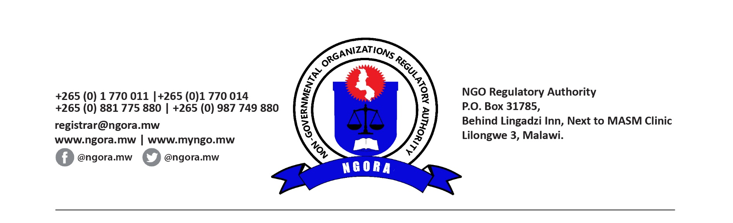

**Advisory Note No one of 2025 on Protecting Your Organization: Ensure Safe Transactions Through Regulated Financial Channels**

**To all non-governmental organizations (NGOs)**,

The NGO Regulatory Authority (NGORA) encourages all NGOs operating in Malawi to conduct their financial transactions exclusively through regulated financial and payment channels. Using formal banking systems and authorized financial platforms enhances transparency, reduces risks of financial abuse, and strengthens compliance with national and international standards against money laundering, terrorism financing, proliferation financing and other financial crimes.

Regulated financial and payment channels provide secure transaction records, minimize the risk of misappropriation, and help protect your organization’s reputation. By adopting this best practice, you help ensure that your organization’s resources remain dedicated to supporting positive change in our communities.

Therefore, NGORA encourages all NGOs to review and strengthen their financial policies to ensure safe, transparent, and compliant practices. For further guidance on regulated financial and payment channels, please reach out to NGORA, the Reserve Bank of Malawi or the Financial Intelligence Authority.

Let’s work together to build a more secure, accountable, and impactful NGO sector in Malawi.

**NGO Regulatory Authority**

***Registering and Regulating the operations of NGOs in Malawi***