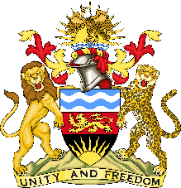 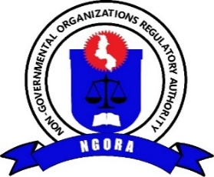

**NGO FUND CALL FOR PROPOSALS**

**Background:**

The Non-Governmental Organization Regulatory Authority (NGORA) is a statutory body established by the Non-Governmental Organization (NGO) (amended) Act, 2022 with a mandate of registering and regulating NGO operations in Malawi. Section 3 of the NGO Act provides for NGORA to create a conducive environment for NGO development through incentives and to promote the development of a strong independent civil society in Malawi. The 2023 NGO Sector Report, reported that over 120 NGOs were dormant and at least 40 NGOs closed mainly due to financial reasons. During the launch of the Report, His Excellency the State President of the Republic of Malawi, Dr. Lazarus McCarthy Chakwera directed the Ministry of Gender, Community Development and Social Welfare (MoGCDSW) and NGORA to put in place strategies that will enhance capacity of the NGOs especially Local NGOs.

It is against this background that NGORA requested Government of Malawi (GoM) for extra resources in the 2024/2025 financial budget which was granted. NGORA has therefore allocated **MK1 Billion** to the NGO Fund from government subvention and NGO fees with an aim of addressing capacity gaps in the operations of NGOs in Malawi.

**Focus Areas:**

The NGO Fund will target the following focus areas: **1. Institutional Strengthening:** This will focus on enhanced institutional operations and thereby improve skills development, project management, financial management and community empowerment; **2. Improving Coordination:** On this, the fund aims to improve the coordination and collaboration of NGOs and government entities as well as coordinating bodies, and **3. Enhanced Monitoring**: This will improve service delivery as NGORA, line ministries and district councils will ably monitor NGO work.

**Eligibility:**

The funds shall be disbursed to entities meeting the following criteria: *1. Shall be a registered NGO with a valid license; and 2. Government line Ministries or District Councils working with NGOs and implementing coordination and monitoring programs of NGOs.*

**Application Process:**

Applicants must complete the official application form which can be downloaded from NGORA’s website ([www.ngora.mw](http://www.ngora.mw)) or can be collected at NGORA Secretariat in Lilongwe and NGORA District Offices across the country or upon request through email. The application should include the following details: • A filled application form; and • Proof of registration and valid license (for NGOs and umbrella bodies). All applications should be submitted online through ***ngofund@ngora.mw or*** in person (at NGORA Secretariat) not later than 31st August 2024.

**Evaluation Process:**

Applications will be evaluated based on the following: • Relevance and impact of the proposed project; • Feasibility and clarity of the proposal; • Organizational financial track record; and • Sustainability and scalability of the initiative • Amount applied for ranges from MK5 million – MK10 Million. Only successful applicants shall be informed within a month of the submission of the application.